Nama: Arrijal Mutaqin

NPM: 0620101016

<https://github.com/ArrijalMutaqin/Pemograman-IV>

**Array 2 Dimensi**

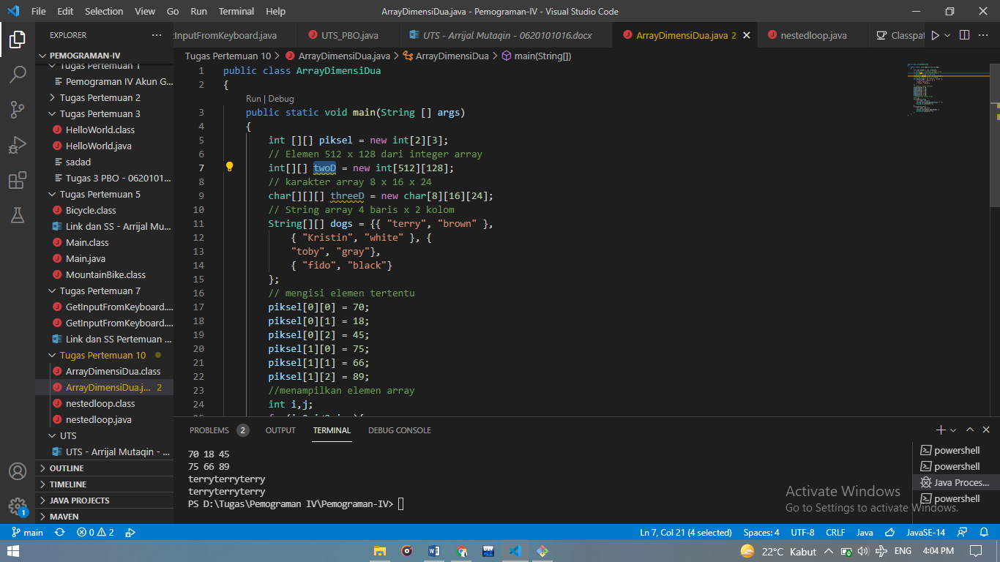

**Nested Loop**

